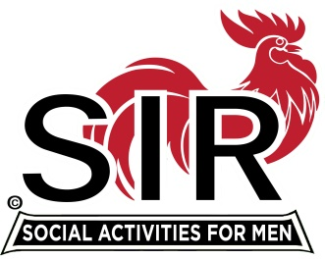
Las Trampas Branch 116
BEC Meeting Agenda
May 17, 2021, 8:30 AM
The Mission of SIR is to enhance the lives of our members through fun activities, events and luncheons – while making friends for life.

8:30 am Call to order; Secretary confirm a quorum

8:35 Secretary –Paul Ramacciotti – Approval of April 19, 2021 minutes

8:40 Treasurer –/Alan Fitzgerald – Report

8:45 Standing Reports
- Membership – Phil Goff
- RAMP Department Head Reports:
- Recruitment
- Activity Coordinator
- Member relations
- Publicity
- Carmel Golf [ Kevin Donahue]
- Covid Compliance [Kevin Donahue]
- Boundary Oak Restaurant Update [Mike Schneider]

9:00 Big SIR Report – Sam Beret

- May 17 monthly meeting agenda
- Special BEC Meeting for Branch Website & Database – May 25 at @ 8:30 am?
- SIR Leadership Symposium for RAMP and Nominating Committee Leaders May 19-20, 2021 @2-4pm

9:15 Little SIR Report - Fred Wachowicz
1. Speaker:
2. Birthday Boys
3. Diversity Team Report

9:25 Branch website & Database Security - Neil Schmidt

9:30 Old Business
New Business
Covid Protocols for Wine Tasting, Amiable Amblers

9:45 Adjourn; Next BEC Meeting, June 21, 2021

Join Zoom Meeting Weblink
https://us02web.zoom.us/j/85332344422
Meeting ID: 853 3234 4422
Passcode: 612956
Dial by home phone: (669) 900-9128

